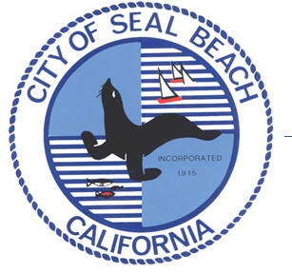

PRESS RELEASE

April 20, 2015

FOR IMMEDIATE RELEASE

I-405 Widening Project Public Meeting

On April 3, 2015, Caltrans released the FINAL Environmental Impact Report/ Environmental Impact Statement (EIR/EIS) which studied the impacts this project may have on the environment. The project will add toll lanes on the I-405 freeway between the I-605 to the SR-73 freeways. The final EIR/EIS was signed and is available for additional public comments until May 4, 2015 (30-day period).

The final document addresses all comments that were submitted by all agencies and the public. A printed copy of the Final EIR/EIS and a digital copy of the technical studies are available for reading at CALTRANS District 12, 3347 Michelson Drive, Suite 100, Irvine, CA 92612 on weekdays (Mon-Fri) from 8:00 a.m. to 5:00 p.m.

These documents are also available to read at the following public libraries during their regular business hours:

- Los Alamitos/Rossmoor Library (12700 Montecito, Seal Beach, CA 90740)
- Mary Wilson Library (707 Electric Avenue, Seal Beach, CA 90740)

In addition, the document is also available to read online at www.dot.ca.gov/dist12/DEA/405/index.php and www.octa.net/405improvement

The City will be hosting a public meeting to update the community on the I-405 project. The meeting will be held:

Thursday, April 23, 2015, 7:00pm
Seal Beach North Community Center
3333 Saint Cloud Drive, Seal Beach, 90740

Comments may be sent via email to: d12.405proj@dot.ca.gov for general information about transportation issues or call the Public Information Office at (949) 724-2000.

Should you have any questions/comments, please contact Sean Crumby, Seal Beach Director of Public Works at (562) 431-2527 ext. 1318 or via email at scrumby@sealbeachca.gov.

